Exotic Sourcing Guide

Video guide can be found here:
https://www.youtube.com/watch?v=OZ82k0-G4fU

Last Updated : Y2025 - M12 - D22

Lexicon
Targeted Pool : Items are in the general Targeted Loot pools, and can be acquitted just by using the targeted loot system or as random exotics from drops and caches.
Pre requirement : Requires blueprint before it is in the General or Targeted Loot pool, some blueprints will come from Project/Quest chains.
Not Targetable : Items are from a specific source, and are not targetable nor will they randomly drop as exotic, items in this category are generally tied to specific content.

Blueprint can be either the reconfiguration or the crafting blueprint,
Meaning that for the project exotics, if someone shares them to you, it will give access to the reconfiguration blueprint, and it will be in your targeted loot pool afterwards.
Or that if you get the Nemesis crafting blueprint from grand washington then you can already try to farm for it with targeted loot.

Target Lootable Weapons
https://docs.google.com/drawings/d/1m_Hwx7eEVcLWkKKj0DSi8383eHHpflVu60BdvH4_Um4
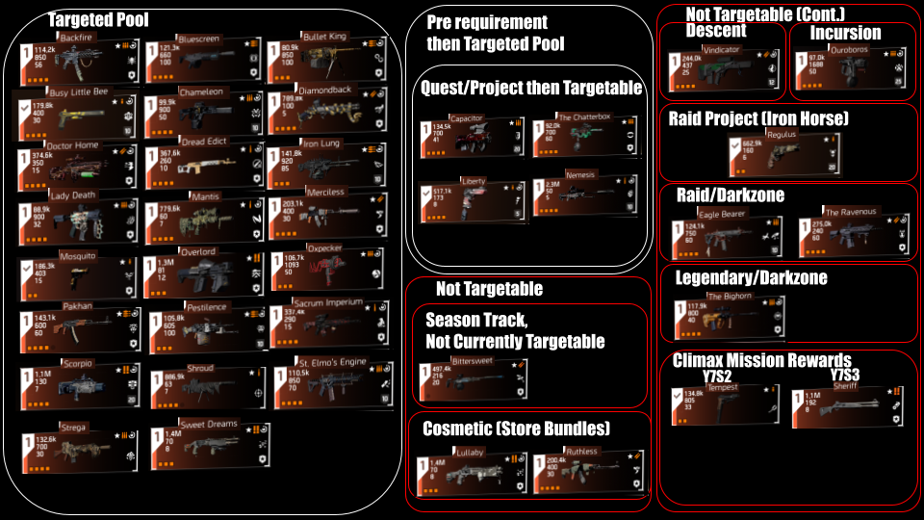

Specials:
Capacitor : 5 Summit challenges to unlock. Sometimes available through Seasonal/Stretch goal caches.
Chatterbox, Liberty, Nemesis : world quests that give the blueprint and usually your first one, (nemesis is available from TL from the point you get the crafting blueprint). Sometimes available through Seasonal/Stretch goal caches.

Bittersweet : Currently not targetable even with owning a blueprint, Available from Season Reward Track, likely will be available in stretch goals at end of season, and targetable after the season.
Lullaby / Ruthless : Preorder and Ultimate edition rewards. Cosmetic reskin of Sweet Dreams and Merciless. Available through the store.

Vindicator : Buyable for NSA Tech from the Descent Vendors, NSA Tech is Descent currency.
Ouroboros : Paradise Lost Incursion, can drop from chest at the end (10%) and a very low chance of dropping from the bosses (1%)
Regulus : Iron Horse raid Project reward, must complete iron horse and then the subsequent projects. Sometimes available through Seasonal/Stretch goal caches.
Eagle Bearer : Dark Hours raid, Drops from chest at the end and a very low chance of dropping from the bosses. DZ, very low drop chance. Drop chance not affected by targeted loot. Sometimes available through Seasonal/Stretch goal caches.
The Ravenous : Iron Horse raid, Drops from chest at the end and a very low chance of dropping from the bosses. DZ, very low drop chance. Drop chance not affected by targeted loot. Sometimes available through Seasonal/Stretch goal caches.
The Bighorn : Legendary Bosses, Specifically one named enemy in mission or summit, even if there are multiple named enemies. DZ, very low drop chance. Drop chance not affected by targeted loot. Sometimes available through Seasonal/Stretch goal caches.
Tempest : Climax mission Y7S2, Guaranteed reward for first Master difficulty completion, Low chance as completion reward depending on difficulty, 1%Normal / 3%Hard / 5%Challenging / 7%Heroic / 10%Master.. Available from Floor 100 Summit as a completion reward after beating the hunters.
Sherrif : (Not yet available, until climax mission release) Climax mission Y7S3, Guaranteed reward for first Master difficulty completion, Low chance as completion reward depending on difficulty, 1%Normal / 3%Hard / 5%Challenging / 7%Heroic / 10%Master.

Target Lootable Gear
https://docs.google.com/drawings/d/1X4retcmGHt4C73WDHcR2B2KPXVscT_x73Jn5Kg_5e-A
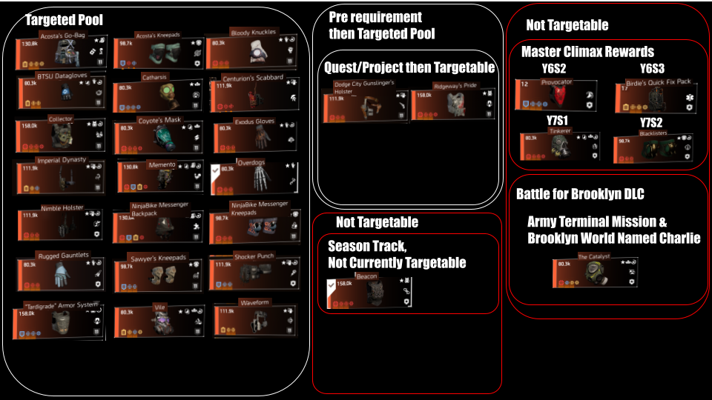
Specials:
Dodge City Holster, Ridgeway’s Pride : Projects, DCH is from a project you receive once past world tiers, Ridgeway is from a questline that leads into a project tied to the summit. Sometimes available through Seasonal/Stretch goal caches.

Beacon : Currently not targetable even with owning a blueprint, Available from Season Reward Track, likely will be available in stretch goals at end of season, and targetable after the season.

Provocator : Climax mission Y6S2, Guaranteed reward for first Master difficulty completion, Low chance as completion reward depending on difficulty, 1%Normal / 3%Hard / 5%Challenging / 7%Heroic / 10%Master.
Birdie’s Quick Fix Pack : Climax mission Y6S3, Guaranteed reward for first Master difficulty completion, Low chance as completion reward depending on difficulty, 1%Normal / 3%Hard / 5%Challenging / 7%Heroic / 10%Master.
Tinkerer : Climax mission Y7S1, Guaranteed reward for first Master difficulty completion, Low chance as completion reward depending on difficulty, 1%Normal / 3%Hard / 5%Challenging / 7%Heroic / 10%Master.
Blacklisters : Climax mission Y7S2, Guaranteed reward for first Master difficulty completion, Low chance as completion reward depending on difficulty, 1%Normal / 3%Hard / 5%Challenging / 7%Heroic / 10%Master.
Catalyst : Battle for Brooklyn item, Chance of drop from final marauder in the Army Terminal mission, chance of dropping from world named boss Charlie in Brooklyn. 1%Normal / 3%Hard / 5%Challenging / 7%Heroic.

Links to my other guides, the Build Collection, DMG/DPS Calculators and many other things:

https://docs.google.com/document/d/15mg-_sjowh5_8bUp2VIBqnDxCDqz-xJOISl0DlG3RDU

